

##### AACS1483 Web Design and Development

**Assignment**

| **Programme : Diploma in Computer Science** | |
| --- | --- |
| **Tutorial Class : Group 6** | |
| **Website Title : Electron Car Company** | |
| | **No.** | **Student Name** | **Student ID** | **Module In Charge** | **Signature** | **Part 1**  **(30%)** | **Part 2**  **(70%)** | **Total**  **(100%)** | | --- | --- | --- | --- | --- | --- | --- | --- | | **1** | **Choo Zhen Hao** | **22WMD07217** | **homepage , payment** |  |  |  |  | | **2** | **Ernest Sua Yii Shien** | **22WMD07536** | **about us, delivery** |  |  |  |  | | **3** | **Leong Hon Yan** | **22WMD07184** | **location, message** |  |  |  |  | | **4** | **Wong Kai Chen** | **22WMD07496** | **contact us , product details** |  |  |  |  | | **5** | **Yong Weng Hong** | **22WMD07169** | **shop with us, customer reviews** |  |  |  |  | | |
| **Lecturer: Loo Sze Phei** | **Practical Tutor : Lim Kah Lok** |
| **Date of Submission: 27-09-2022** | |

**Assignment: Use web development tool, HTML, Cascading Style Sheets (CSS) and JavaScript to create a website for conducting the business online and fulfilling the customer needs.**

**Assessment Rubrics – Assignment Part 1 (30 marks)**

| Proposal -**Criteria** | **Marks** | **Excellent** | **Good** | **Average** | **Poor** | **Score** |
| --- | --- | --- | --- | --- | --- | --- |
| **CLO 3: Develop websites to cater for different types of products or services in the business world. (A2, PLO7)** | | | | | | |
| Planning   * Description of the organization * Website objectives * Potential users * Information the users need * Proposed deliverable | 15 | Excellently define all the required information.  (12 –15) | Correctly define most of the required information.  (9 – 11) | Correctly define some of the information. The rest are either incorrect or missing.  (6 – 8) | Most of the information is missing, incomplete or incorrect.  (0 – 5) |  |
| Web Analysis   * Functions or modules | 15 | Excellently define all the required information.  (12 –15) | Correctly define most of the required information.  (9– 11) | Correctly define some of the information. The rest are either incorrect or missing.  (6 – 8) | Most of the information is missing, incomplete or incorrect.  (0 –5) | | Name | Mark | | --- | --- | | 1.Choo Zhen Hao |  | | 2.Ernest Sua Yii Shien |  | | 3.Leong Hon Yan |  | | 4.Wong Kai Chen |  | | 5.Yong Weng Hong |  | |  |  | |
| **Total (30 marks)**  Comments (if any):  _____________________________________________________________________________________________________________________________________________________________________________________________________________________________________________________________________________________________________________________________________________________________________________________________________________________________________________________________ | | | | | | | Name | Mark | | --- | --- | | 1.Choo Zhen Hao |  | | 2.Ernest Sua Yii Shien |  | | 3.Leong Hon Yan |  | | 4.Wong Kai Chen |  | | 5.Yong Weng Hong |  | |  |  | |

**Assessment Rubrics – Assignment Part 2 (70 marks)**

| **Criteria** | **Marks** | **Excellent** | **Good** | **Average** | **Poor** | | **Score** | |
| --- | --- | --- | --- | --- | --- | --- | --- | --- |
| **CLO 2: Demonstrate the web development using web development tool, Cascading Style Sheets (CSS) and JavaScript.** | | | | | | | | |
| **Functionality & Complexity of the Website Module using the following elements:**   * Media elements (text, graphic, audio, video and animation) * Hypertext and hypermedia * List * Formatting * Hotspot / image map * Table * Form * CSS for all of the GUI design (use External Style Sheet effectively) * JavaScript | **40** | Excellently completed more than 80% of the required functionalities correctly using all the listed elements. High level of complex algorithms and programming skills.  (32 – 40) | Completed more than 60% of the required functionalities correctly using most of the listed elements. Average level of complex algorithms and programming skills.  (21 – 31) | Averagely completed more than 40% of the required functionalities with some minor errors. Only used some of the listed elements.  Low level of complex algorithms and programming skills.  (11– 20) | Not able to complete most of the required functionalities correctly. Only used few of the listed elements.  Poor level of complex algorithms and programming skills.  (0 –10) | |  | |
| **Creativity in Modules’ Function & Interface Design** | **10** | Excellent creativity in module function and interface design.  (9 – 10) | Good creativity in module function and interface design.  (7 –8) | Average creativity in module function and interface design.  (5 – 6) | Poor creativity in module function and interface design.  (0 – 4) | | | Name | Mark | | --- | --- | | 1.Choo Zhen Hao |  | | 2.Ernest Sua Yii Shien |  | | 3.Leong Hon Yan |  | | 4.Wong Kai Chen |  | | 5.Yong Weng Hong |  | |  |  | | |
| **User Interface Features** | **20** | Excellent design consistency and interface usability, visual effect and interactivity.  (16-20) | Good design consistency and interface usability, visual effect and interactivity.  (11-15) | Average design consistency and interface usability, visual effect and interactivity.  (6-10) | Poor design consistency and interface usability, visual effect and interactivity.  (0 – 5) | | | Name | Mark | | --- | --- | | 1.Choo Zhen Hao |  | | 2.Ernest Sua Yii Shien |  | | 3.Leong Hon Yan |  | | 4.Wong Kai Chen |  | | 5.Yong Weng Hong |  | |  |  | | |
| **Total (70 marks)**  Comments (if any):  **________________________________________________________________________________________________________________________________________________________________________________________________________________________________________________________________________________________________________________________________________________________________________________________________________________________________________________________________________________________________________________________________________** | | | | | | | Name | Mark | | --- | --- | | 1.Choo Zhen Hao |  | | 2.Ernest Sua Yii Shien |  | | 3.Leong Hon Yan |  | | 4.Wong Kai Chen |  | | 5.Yong Weng Hong |  | |  |  | | |

**Plagiarism Statement**

The university college views cases of plagiarism or collusion by students very seriously. Any students who intentionally plagiarize or collude in any part of their assignments/projects or written work threatens the values of academic work and undermines the credibility and integrity of the University College’s awards. Plagiarism or collusion discovered at any stage of the student’s course of study will be dealt with appropriately by the School. Such offender shall appear before a panel of enquiry at the School and appropriate punishment will be meted out. Punishment may include failing the student for the assignment or project, re-submission of another piece of work or downgrading the work to the maximum of a pass grade even if the actual grade achieved was higher.

**What constitutes “Plagiarism” and “Collusion”?**

Plagiarism according to the Oxford Advanced Learner’s Dictionary of Current English means “take and use somebody else’s ideas, words, etc. as if they were one’s own.”

**Plagiarism** can take the form of reproduction without acknowledgement from published or unpublished works of others including materials downloaded from computer files on the Interne.

Student’s work submitted for assessment is accepted on understanding that it is the students’ own effort without falsification of any kind. Acknowledgement to the source must be made if students had replied on any sources for information with appropriate reference being made in their work.

**Collusion** can be deemed to be a form of plagiarism involving the unauthorized co-operation between two or more people with deceptive intention.

Collusion can take the form of two or more students producing a piece of work together but one intentionally passing it off as his work with the knowledge of the others. Student may have submitted the work of another as his own with consent from that other student. In such cases, both parties are guilty of collusion.

**Obligations of students**

Students are required to sign a declaration that the work submitted such as coursework assignment, essays and projects, etc. is their own work and that they have not in any way knowingly allowed another student to copy it. It will be assumed that all submitted work is that of the students’ own work.

Students are expected to familiarize themselves with or make use of method(s) of citing other people’s work in accordance with acceptable referencing



**AACS1483 Web Design and Development**

**Plagiarism Statement Form**

**We confirm that the submitted works are all our own work and are in our own words.**

|  | **Name (Block Capitals)** |  | **Student ID** |  | **Signature** |
| --- | --- | --- | --- | --- | --- |
| **1.** | **CHOO ZHEN HAO** |  | **22WMD07217** |  |  |
| **2.** | **Ernest Sua Yii Shien** |  | **22WMD07536** |  |  |
| **3.** | **Leong Hon Yan** |  | **22WMD07184** |  |  |
| **4.** | **Wong Kai Chen** |  | **22WMD07496** |  |  |
| **5.** | **Yong Weng Hong** |  | **22WMD07169** |  |  |

| **Tutorial Group :** | Group 6 |
| --- | --- |
| **Date :** | 27/09/2022 |

**Table of Content**

**Contents**

Part 1 - Chapter 1 8

Description of the organization (1 Page) 8

Website Objectives (1 Page) 9

Potential Users of the Website (1 Page) 10

Information that Users Need and Want (1 Page) 11

Proposed Deliverable of the Final Website (1 Page) 12

Part 1 – Chapter 2 13

Member 1 Choo Zhen Hao (1 Page) 13

Member 2 Ernest Sua Yii Shien (1 Page) 14

Member 3 Leong Hon Yan (1 Page) 15

Member 4 Wong Kai Chen (1 Page) 16

Member 5 Yong Weng Hong (1 Page) 17

Part 2 18

Member 1 Choo Zhen Hao 18

Member 2 Ernest Sua Yii Shien 19

Member 3 Leong Hon Yan 20

Member 4 Wong Kai Chen 21

Member 5 Yong Weng Hong 22

List of References 23

# Part 1 - Chapter 1

## Description of the organization (1 Page)

    Automobile industry in Malaysia is growing and developing with the years. It is the third largest automobile industry in Southeast Asia. This industry also contributes to Malaysia’s economy and GDP . It contributes  4% of the increase of Malaysia’s GDP. The automobile industry also offer many working chances for local residents in Malaysia. The automobile industry hires almost 350,000 Malaysians . So, Malaysia’s government strongly encouraged and supported local car manufacture. Electron Car Company is one of the local companies that is heavily supported by Malaysia’s Company and economy policy.

     Electron Car Company is the leading of Malaysia’s car manufacturer.It is also among the largest Automobile Company in Malaysia. Electron has manufacturing centres in Shah Alam and Tanjung Sepat and also components plants operating for company manufactures. Electron Car are always improving themselves and trying to make better and perfect for their manufacture parts. Along the years , Electron have produced variety designed of car and published in about 26 country , which majority in Asia Countries.

     Electron have cooperated with other companies to improve itself and learn new technology. For example , Electron has cooperate with Mitsubishi Motors with sharing technology and modern design . One of the more classic technologies brought by Electron is CamPro engine with 1.6 litre Campro Charge Full Efficiency(CEF) with a good performance that able to compare with 2.0 litre engine. With this technology ,Electron have achieved a historical first achievement for Electron. Electron Car have archive 5 Star Australasian New Car Assessment Program (ANCAP) Safety Rating in 2010.Electron also get many other rewards within these years. All these are certificates given to Electron.

     Electron have majority sales in local market . Among the most popular series car are ELECTRON series and X series. Electron have a great reputation among the consumer as its reasonable price and great user’s practical experience. In 2000s , Electron make good profits and achievement. Its made four of ten sold cars in local market are Electron car.

     Now ,Electron currently focus on major structural and internal changes to develop more upcoming and new modern to get more presence in the international market. Such changes can increase the profitability of company and stimulate the whole automotive industry as well as the auto accessories market. This enables Electron Car Company to compete with other countries like China and Thai companies. Electron can lead Malaysia's automobile industry to a higher level.

## Website Objectives (1 Page)

A large number of people are looking for the car these days by going directly to a search engine to find answers. The purpose of the website was to update the latest trend of our product and to attract more customers to go through our website.

It might take a bit of work to develop it and take some time to get the customer's trust. But it is worth the challenge. Our company will provide the best service for our customer and our products will be in good quality for sure. The purpose is to build our brand awareness. In addition, we hope that our marketing field can increase to the top world rankings.

## Potential Users of the Website (1 Page)

This website is used to sell the cars of the company called Electron and it will have all kind of people using it except for children and old-aged people.This doesn’t mean that they won’t use it either because there will always be someone that is interested in cars and will want to check them out in the website.So we have made this website to be as easy and convenient to use for all ages and sizes.We had also made a very detailed about us website for the history-lovers for them to learn about us and what we did to the cultural aspects as well as the events of what made us  to be the oh-so great company now.

## Information that Users Need and Want (1 Page)

In this webpage, it provides some important information that the users need like company history, awards, order information, product details, branch address, etc. The users may change their perspective after they saw the information in the webpage. Information in the webpage can build up the image of the company so that they are not just believe our product but they will also trust our company management based on the experience.

We believe the information in the webpage can clarify some misunderstanding in social media. We always bring the best quality to the customer. We also convince customers by providing some customer product reviews. We believe this achievement can let the customers buy the product through us.

## Proposed Deliverable of the Final Website (1 Page)

Storyboard: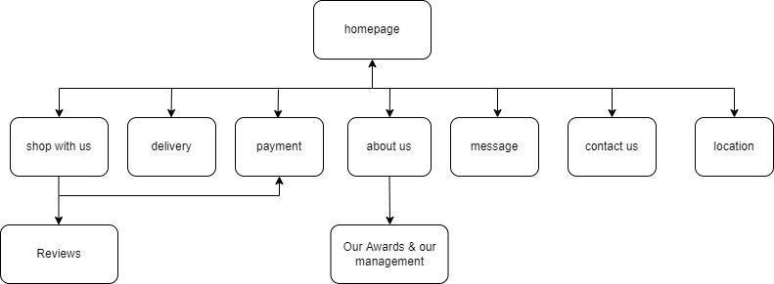

Project Lifecycle: Start date – 16/09/2022 , end date – 24/09/2022 , duration – 8 days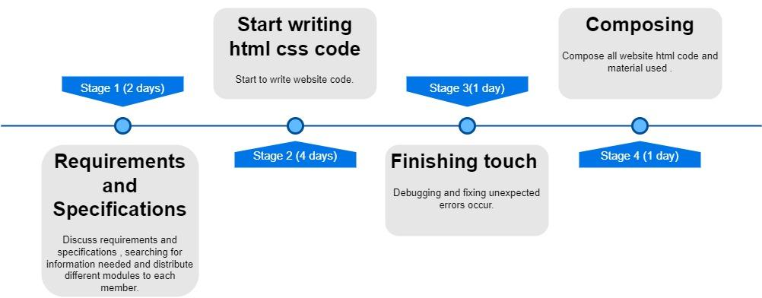

# Part 1 – Chapter 2

## Member 1 Choo Zhen Hao (1 Page)

Function of homepage module

This is the first page of the website, it will display navigation links to all other web pages and autoplay a promotional video .A “welcome” sound effect will play after the webpage is loaded. It will also show our 3 main best selling cars

Function of payment module

This consists of 2 different web pages which are billing address and payment. Users can key in their billing address and payment details of their credit cards here using the form. Upon completion of submitting the details, a pop up will appear to inform the user that their info is successfully recorded.

## Member 2 Ernest Sua Yii Shien (1 Page)

Function of About Us Module

There are four submenu web pages under About Us, that is brand story webpage , awards webpage , management webpage and manufacturing webpage. These webpages are created to give a better understanding to user about Electron Car Company when viewing the web pages. These webpage’s contents are designed in reveal form when scrolling down the webpage . Brand story webpage will briefly introduce Electron while the management webpage will introduce our company’s management class and leaders. In the awards webpage , many awards that were given to Electron in recent years are shown in the webpage. These all are the certificate for Electron and the confidence given by our customers. Lastly, the manufacturing webpage have present about our company’s manufacturing arrangement and introduces our company’s manufacturing centre. As several manufacturing centres are shown, customers are able to have a roughly understanding about our manufacturing flow and see our improvement over the years.

Function of Delivery Module

Delivery webpage will show a form that requires users to fill up their delivery details to make Electron Car Company delivery process more smoothly. In this form, customers are requested to fill up their first name and last name , phone number , email , postcode and delivery address. They need to select their option about delivery method and state. All elements are required to fill up according to the respective format or pattern as Boolean attribute, <required> are added in the elements in this form. When clicking the submit button, it will automatically label out certain columns which haven’t fill up or filled up with the wrong format. When clicking the submit button after all the user’s input has fulfilled the requirement, the form will be send to our company server, http://www.deliveryinfo.com/electron/customer. An alert message “Your delivery info have been recorded.” will be displayed to give confirmation info to customers.

## Member 3 Leong Hon Yan (1 Page)

Module – Message

This page will show a message on this webpage. The motive of creating the message is to ensure the customer can communicate with our staff in 24/7. The users can communicate anytime to ensure they can raise their question anytime and anywhere. Our staff will reply as soon as possible. The customer can get the answer soon. Customers don’t need to raise their question physically. They can use this function to save their time and money.

Module – Location

This page will show our branch location in Malaysia. Customers can check the latest address before they visit our branch physically. Other than that, we also provide our headquarters address so that they can come anytime within the office hours. Customers can search our location with copy the coordinates in the webpage.

## Member 4 Wong Kai Chen (1 Page)

Module - Product Details

Detail of cars is made to ease the consumer and let them view the photos of their going-to-be car and view the beauty of their car in full resolution. There are 30 photos for 3 different cars and it’s for model x-50,Civic and Accord.We as Electron strive to fulfill the consumers satisfaction and we had taken photos of every inch of the car models into the photos. The photos had taken different point of views for the cars and also the interior aswell.We even take photos of the window controls just to not miss the functions that is available for the consumer to see.There’s also a small gallery below the slideshow to give the consumer a bit of insight as well as easier to guide as well.Since you can just show the picture you want into the slideshow by pressing on the photos in the gallery.The gallery is also very obvious on which photo is displayed on to the slideshow because of the transparency of other photos will make the only one non-transparent be the obvious one to be on the slideshow.There’s also a button below that will guide the consumer to the details about the car models and their specs.

There’s a table that is shown clearly on what specs of each car models and show what their good at.The fact that it is put in a table and easily comparable to each other is very convenient to the consumer as well as to the experts as well.Since this table is non-car enthusiast friendly and also very detailed to the car experts as well.

Module- Contact Us

Contact between the company and the consumer is very important to business as well as any relationship goes.We as Electron strive to give consumer the best service so we made the contact us website as easy as possible for any people no matter the age and size to contact us as fast as they can.We also color coded the text boxes to indicate if the format of the input is correct or wrong to be more convenient as well as enhancing customer experience.We even provided the format to the telephone number to avoid customers typing out the wrong format.There’s also a reason option for you to choose so that we can contact you immediately depending on the seriousness of the situation.

## Member 5 YONG WENG HONG (1 Page)

Function of Shop With Us Module

The shopping cart contain the image of the car. User can select their car at the button below. User also can refer to their price. User can select the colors, type of car and the models of car they want. After choosing the car spec they can proceed to the payment.

Function of Customer Reviews Module

Base the website we can see the comment that have been given by the customer. Beside we can observe the rate of the customer give and view the average rate.

# Part 2

## Member 1 Choo Zhen Hao

**HOMEPAGE** - This is the first page that users will see when they open the website. This homepage consists of all navigation links to all other web pages and will auto play a promotional video. Users can click on the “learn more about our car” button to see how we manufacture our cars. A “welcome” sound effect is also played when the web page is loaded.

It also displays 3 of our best selling cars , users can click on it to see the product details.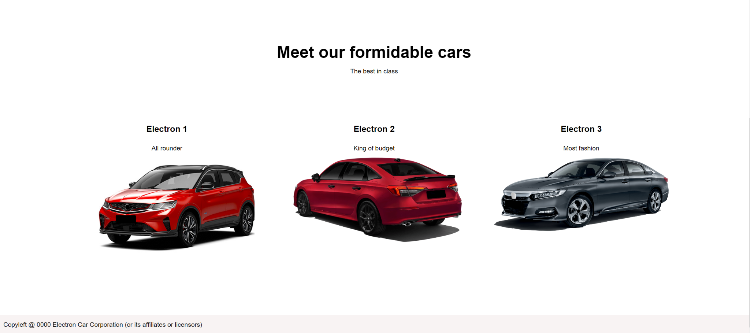

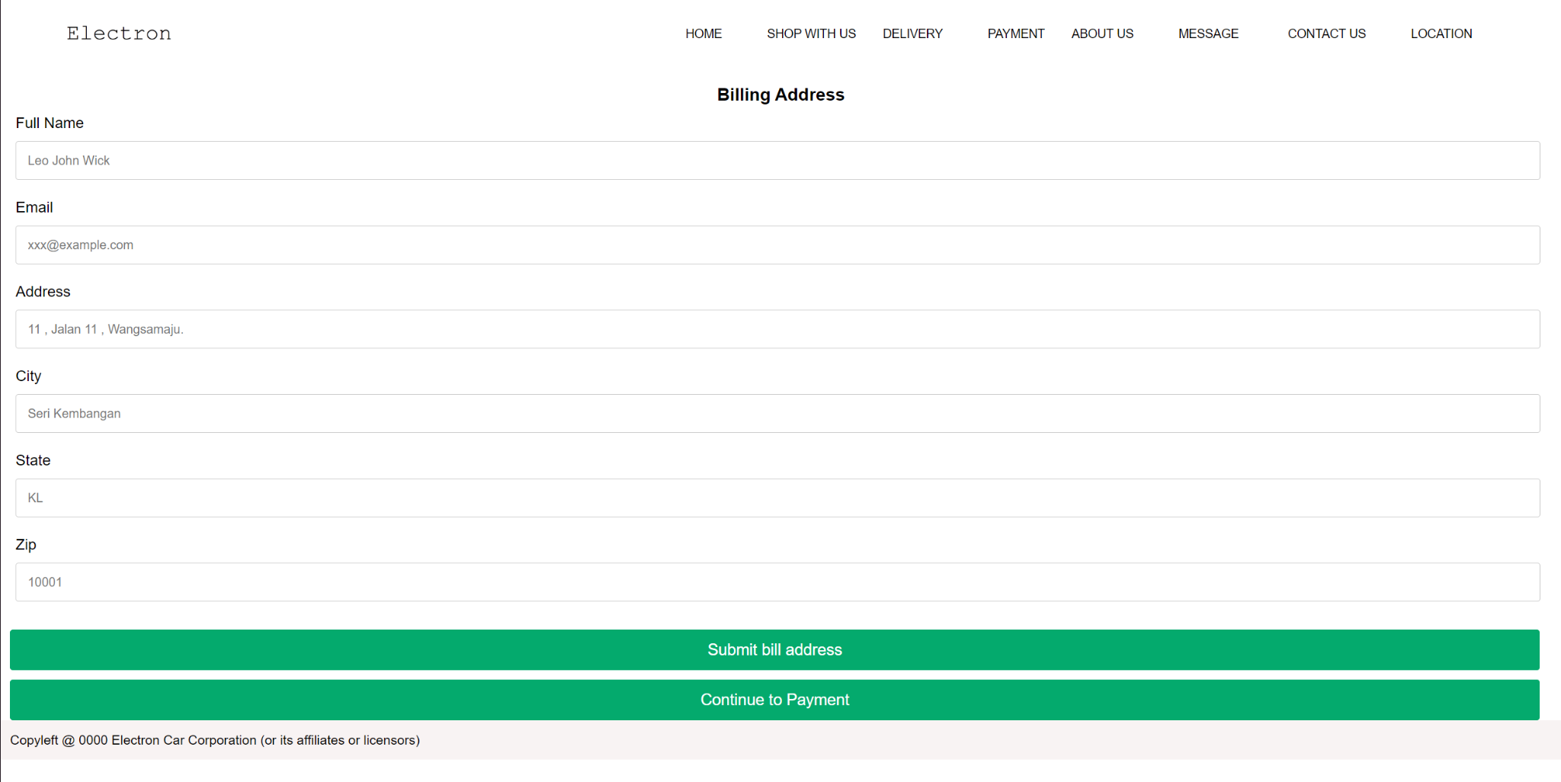

**PAYMENT** - The payment navigation link in the header will bring users to this billing address page to let users fill in their billing address details. They have to enter every text box in order to submit their billing address details , a “Your bill address have been recorded”message box will pop up upon successful billing address submission.User can then click the confirm to payment button to fill in their card info.

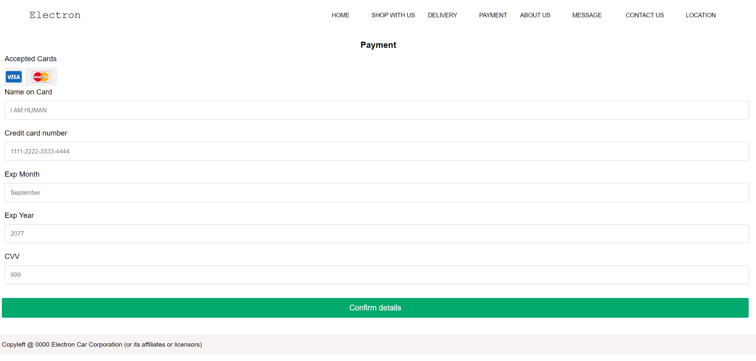

Users will then have to fill in their VISA or MasterCard card details. A “Your payment details have been recorded” message box will pop up upon successful confirmation of details.

## Member 2 Ernest Sua Yii Shien

**Delivery**

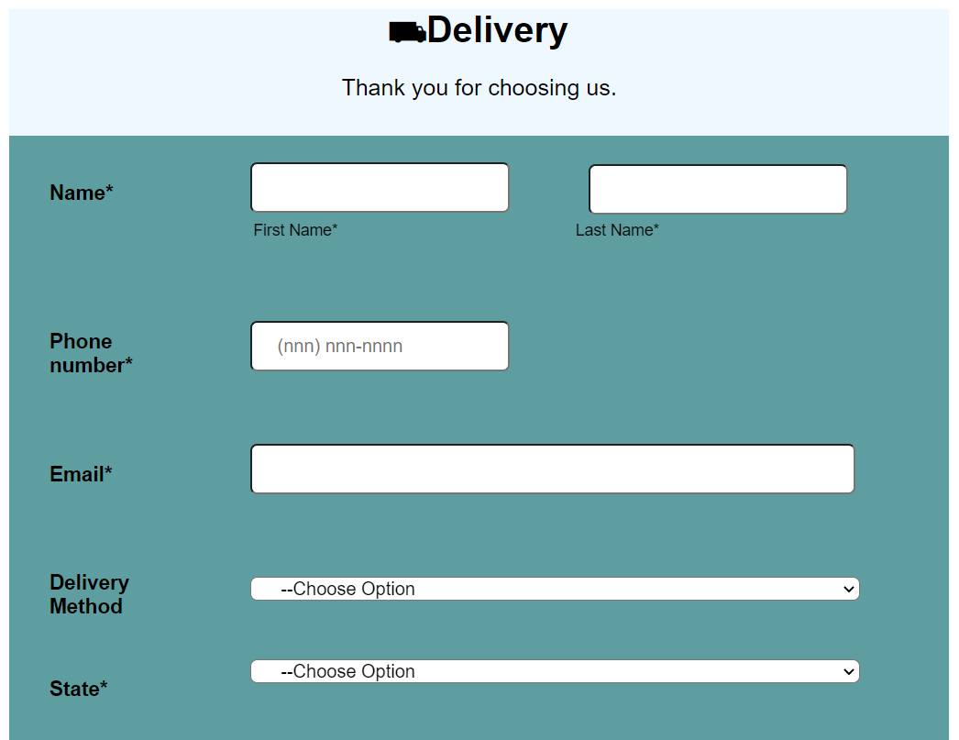

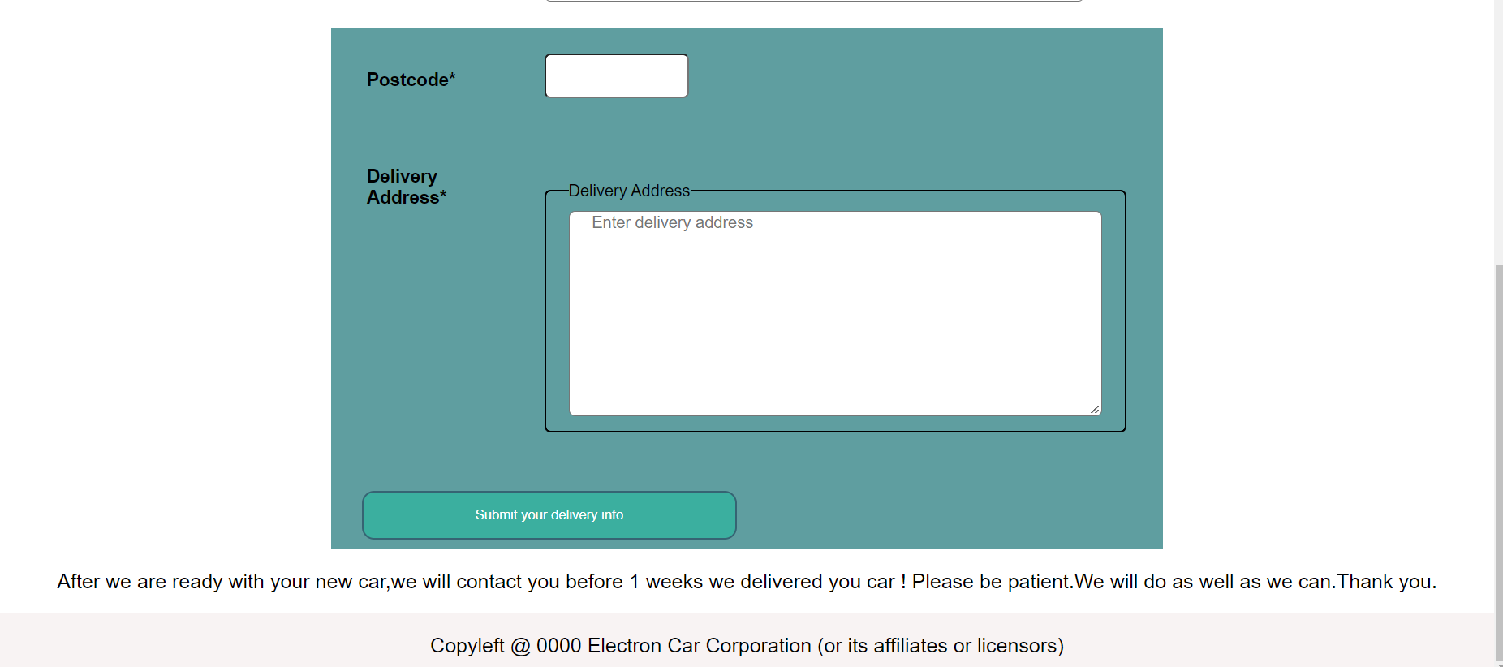

This is delivery webpage that shows a form that require user to fill up their delivery details.In this form,user have to fill up their name,phone number,email,postcode and delivery address.Delivery method and state also have to selected.All details have to be fill up in the require format.

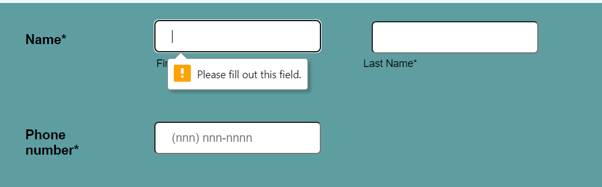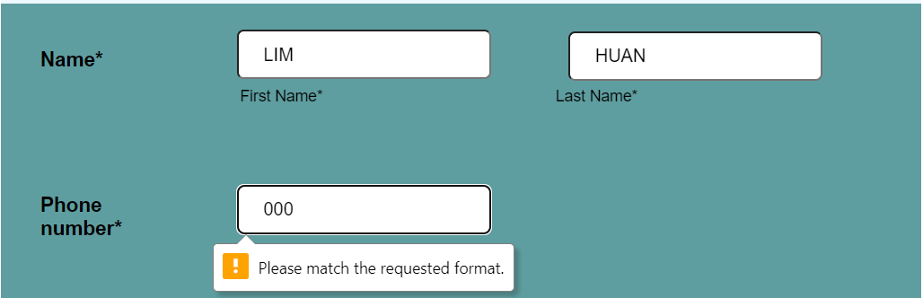

An alert information will be shown at a certain column if users do not fill up that information or do not follow the pattern required.

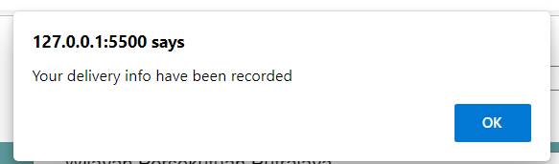

An alert message will be shown when the users click the submit button as all the info fill up correctly.

**About Us**

There are four submenu web pages under the About Us section.

*Brand Story webpage:*

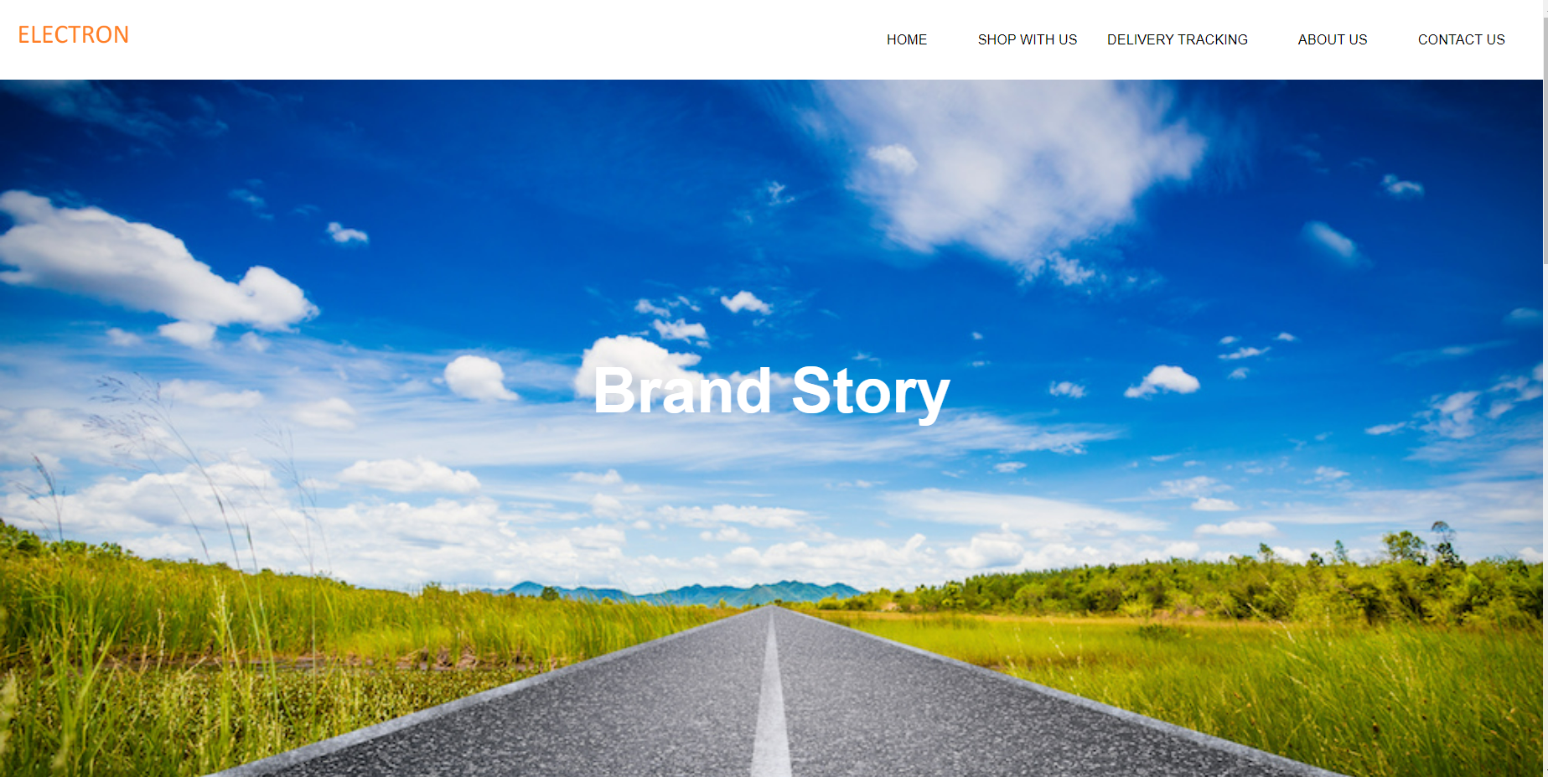

Brand Story page briefly explains about the Electron Car Company.Have two hyperlink will show in the bottom part of the web page to link to management webpage and awards webpage.

*Awards webpage:*



Awards page shows the awards given for our company in recent years.One hyperlink will show in the bottom part of the web page to link it to the management web page.

*Management webpage:*

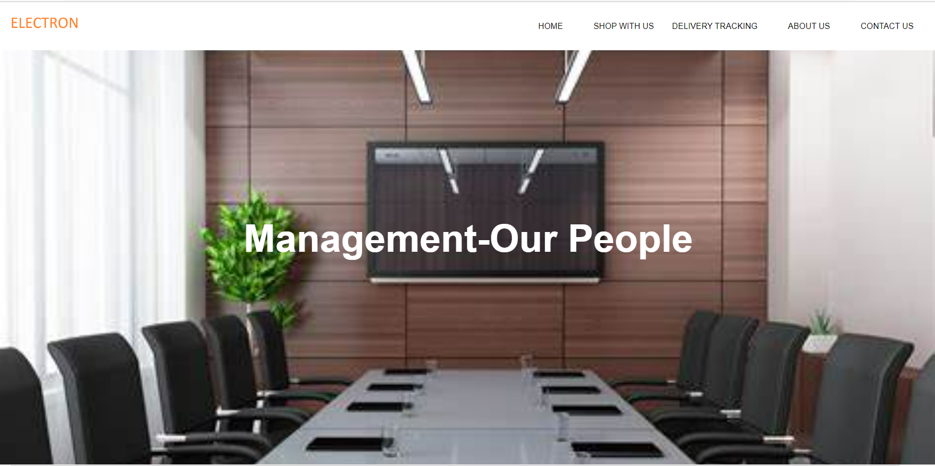

Management web page introduces our company’s class and leaders.

*Manufacturing webpage:*



Users can see our company’s manufacturing by click the “learn more about our car” button in the home page.Manufacturing webpage presents our company’s manufacturing center.

## Member 3 Leong Hon Yan

***Location***

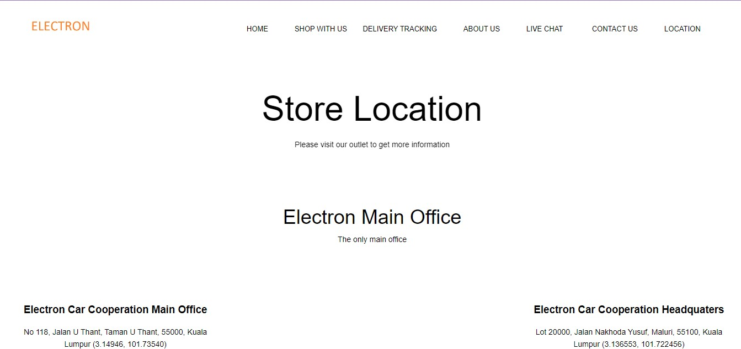

This is the location page. It shows our branch address. Users can visit the nearest location by copying the address or coordinate given. Users can scroll down to find the nearest outlet. After users copy the address, users can paste the location in navigation apps like Google Maps and Waze to visit our branch. We also provide our headquarter location and complex center location so that the users can repair their vehicle at the location provided. Coordinates are given to know the actual location of our branch.

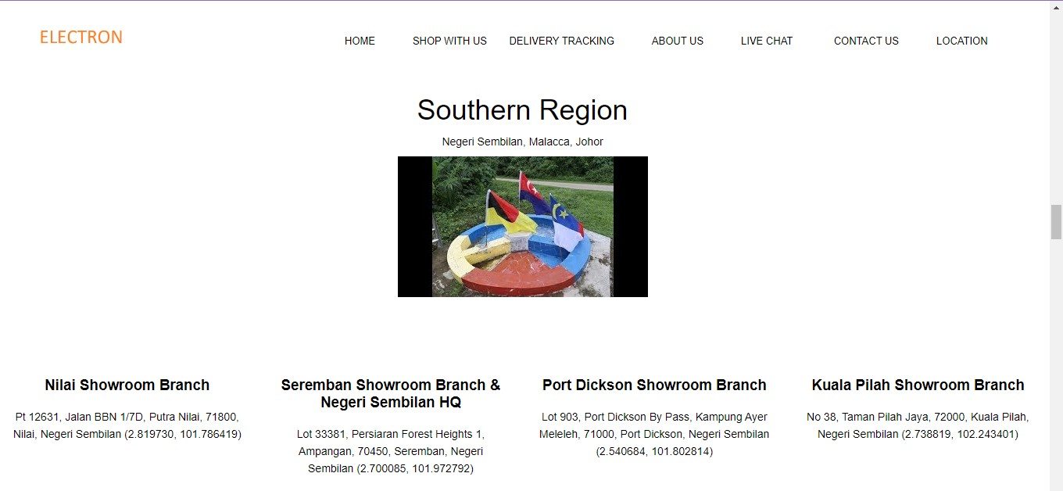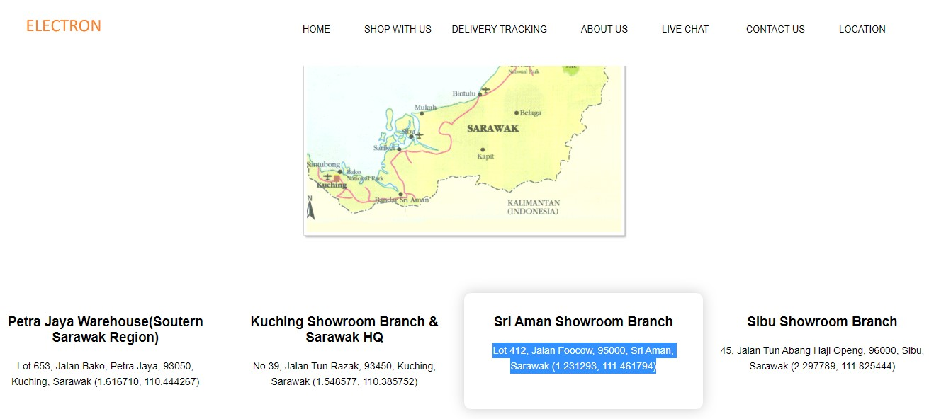

***Live Chat***

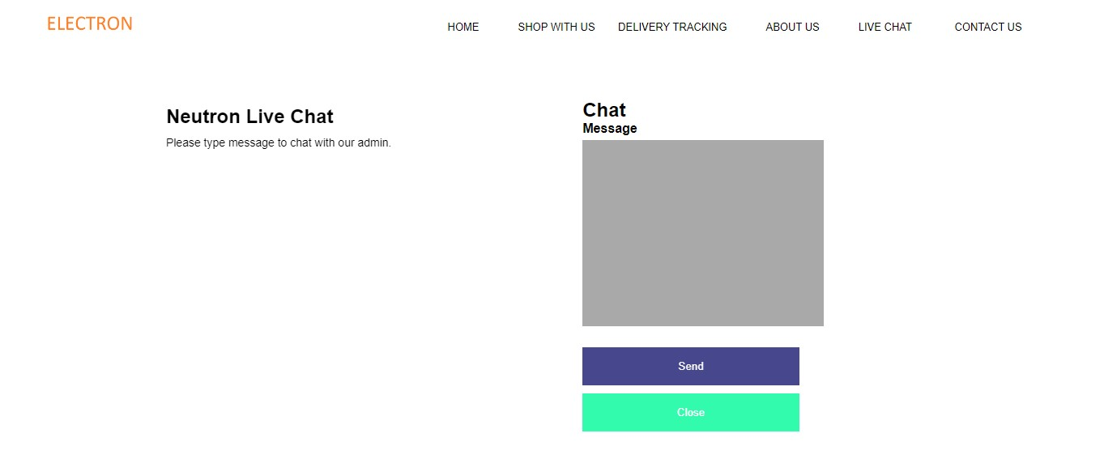

This is a live chat page. Users can communicate with our staff by typing in the comment section. After finishing typing a message, users must send the message so that our staff can receive the message. Once you send the message, it will show “Your message has been sent successfully”. Our staff will reply back as soon as possible.

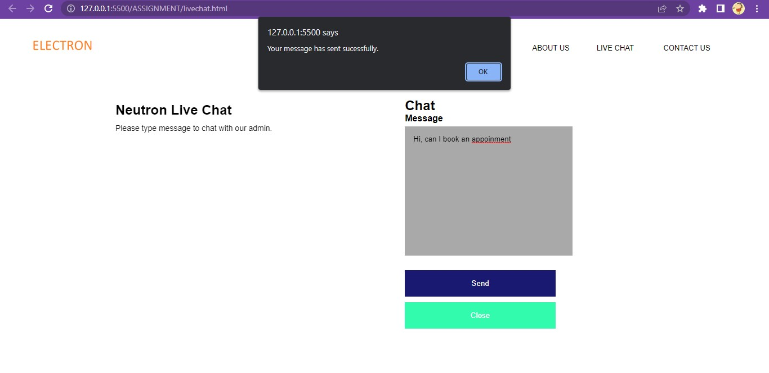

## Member 4 Wong Kai Chen

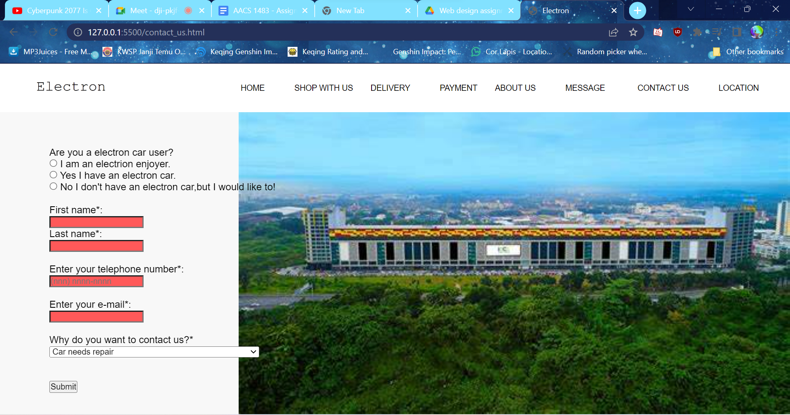

We color coded the text boxes to indicate if the format of the input is correct or wrong to be more convenient.Red in imvalid input and green in correct input.So basically the consumer can start with choosing if they’re an Electron car user or not and then typing the first name last name.Then,the consumer will type in the telephone number.We have provided the format to the telephone number to avoid customers typing out the wrong format.There’s also a reason option for you to choose so that we can contact you immediately depending on the seriousness of the situation.Lastly just press submit and the customer support team will contact you as soon as possible.

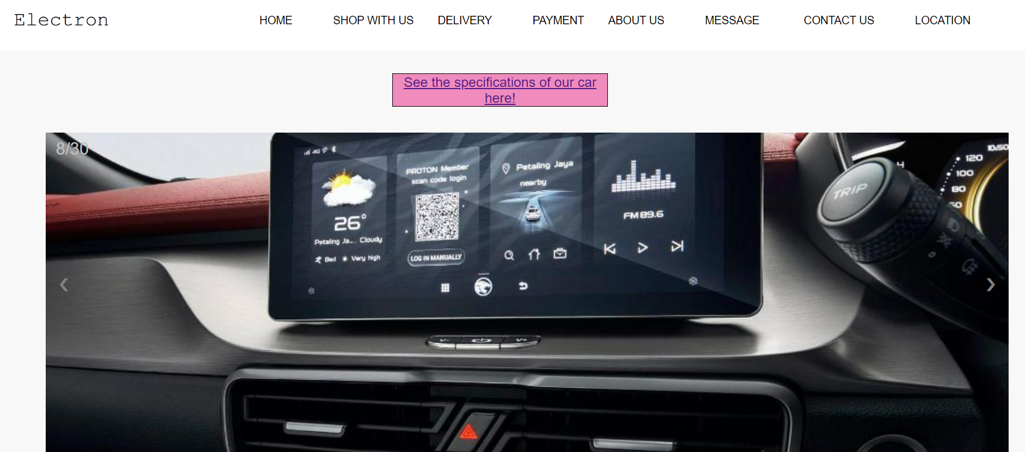

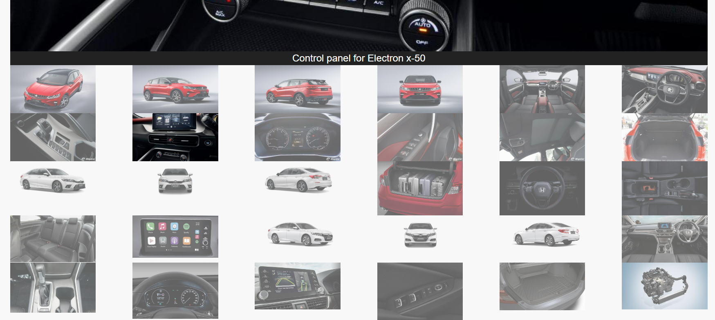

Detail of cars is made to ease the consumer and let them view the photos of their car and view their car.There are 30 photos for 3 different cars and it’s for model x-50,Civic and Accord.There’s also a small gallery below the slideshow to guide easily between photos.Since you can just show the picture you want into the slideshow by pressing on the photos in the gallery.The gallery is also very obvious on which photo is displayed on to the slideshow because of the transparency of other photos will make the only one non-transparent be the obvious one to be on the slideshow.There’s also a button below that will guide the consumer to the details about the car models and their specs.

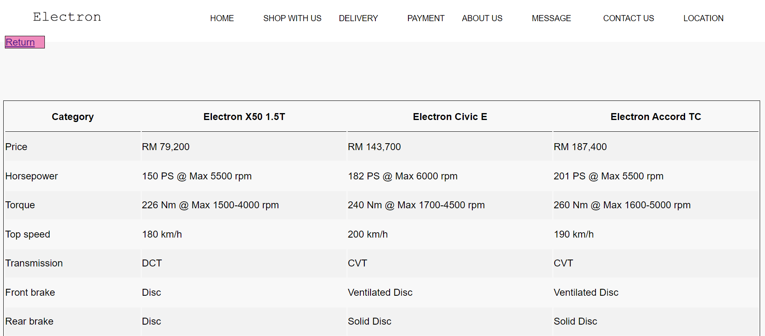

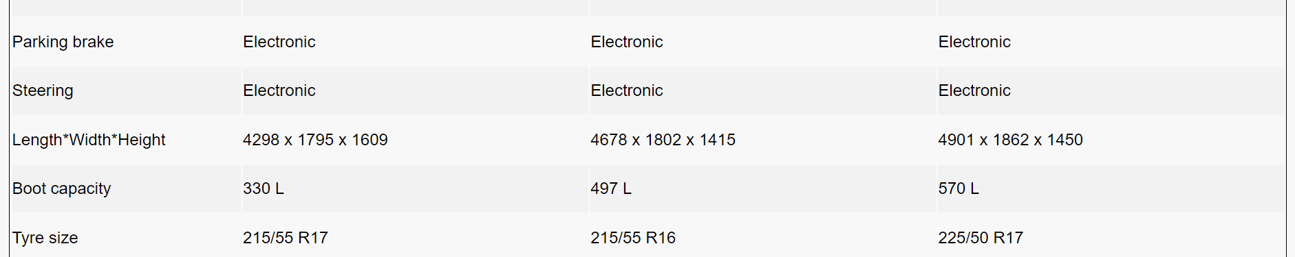

There’s a table that is shown clearly on what specs of each car models and show what their good at.It is put in a table and easily comparable to each other is very convenient to the consumer as well as to the experts as well.This table is non-car enthusiast friendly and also very detailed.There’s a pink button that is captioned return that brings consumer back to the gallery of the cars.

## 

## 

## 

## 

## 

## 

## 

## Member 5 Yong Weng Hong

Shopping Cart

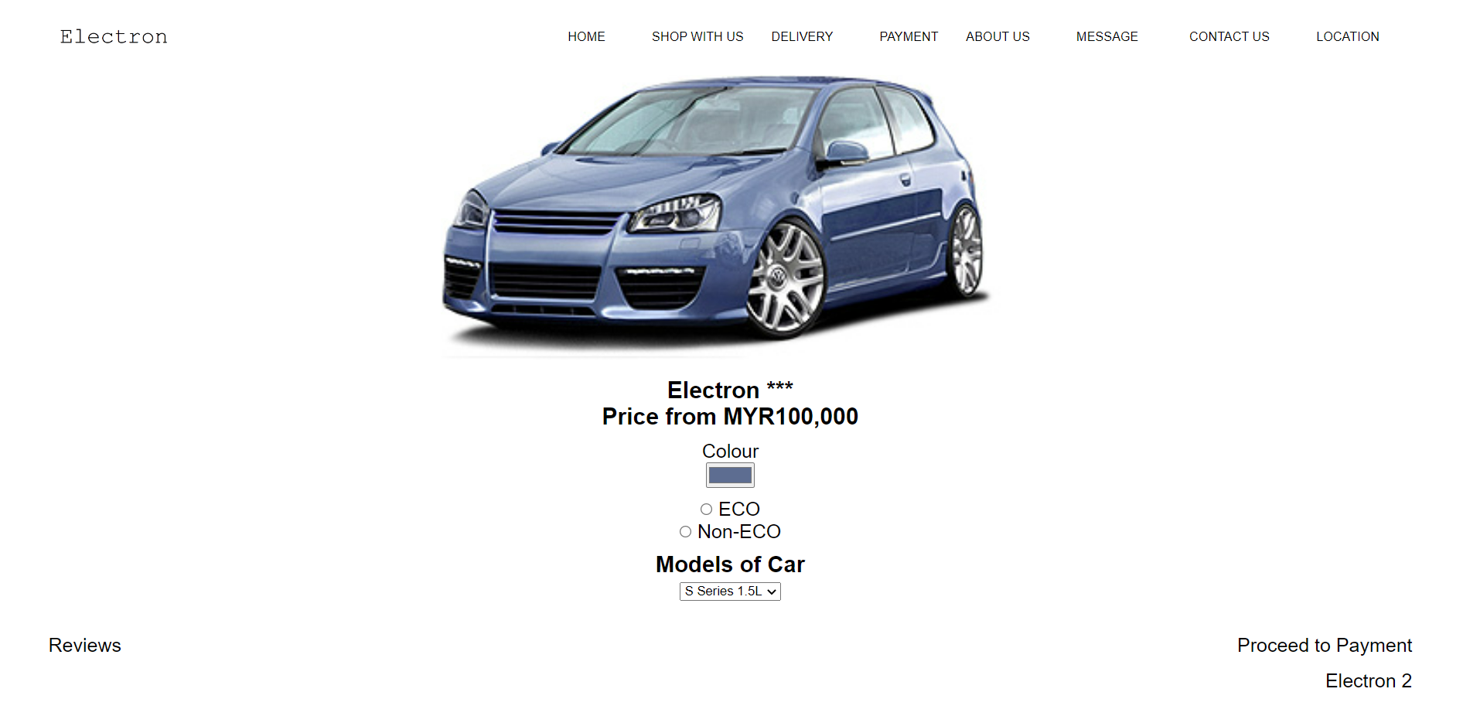

Base on the pictures we can see that user can select their own car color, type of car and the models of car. User can view different car by click to the button below. At the button right side, user can straight away proceed to their payment after selecting the car .While at the left side, user can go to the customer review.

Customer Reviews

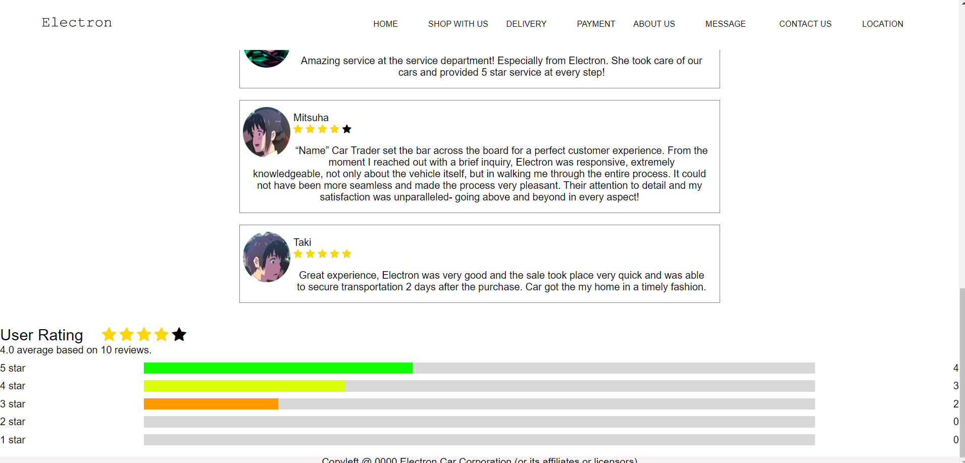

From here the user can view the comment from the other customer. Besides, the user also can view the average rate.

# List of References

-Rajkamal,2014,Top 10 Biggest Automobile Manufacture In The World, viewed by 20 September,<https://www.drivespark.com/img/2014/07/28-cover.jpg>

-18 Funny Employee Awards Your Team Will Love Employee Experience，viewed by 20 September，

<https://www.kazoohr.com/wp-content/uploads/2017/04/12-Funny-Employee-Award-Ideas-1-800x416.png>

-Max Meadow,2016, cornerstones-continuing-and-fruitful-journey , viewed by 20 September ,<https://tse2.mm.bing.net/th?id=OIP.4ZTaVturw3zqpUrDSTRdqgHaE8&pid=Api&P=0>

- Workspace Solution,2018, 5-items-of-conference-room-av-equipment-you-shouldnt-be-without,viewed by 20 September , <https://tse3.mm.bing.net/th?id=OIP.TwymnfD_2MZEBDE2a_aFRgHaEm&pid=Api&P=0>

- Proton-has-a-new-non-executive-chairman-dato-sri-syed-faisal-albar, viewed by 20 September , < https://www.dsf.my/wp-content/uploads/2016/05/Dato-Sri-Syed-Faisal-Albar-600x400.jpg>

- Proton ,viewed by 20 September ,< https://assets.theedgemarkets.com/_20190114194512_zhar-abdul-hamid.jpg?null>

-Proton , viewed by 20 September ,< https://www.internationalinvestor.com/wp-content/uploads/2017/08/Ahmad-Jauhari-Yahya-Cenergi-SEA.jpg>

- Proton, viewed by 20 September ,<https://tse3.mm.bing.net/th?id=OIP.sWla-g2BO42w5fPTOfu4wAHaHa&pid=Api&P=0>

- Proton, viewed by 20 September , <https://tse1.mm.bing.net/th?id=OIP.XpH8063kDhRtz54MbldyzQHaJO&pid=Api&P=0>

- https://www.proton.com/

-Proton car specs,viewed by 24 September

-https://www.wapcar.my/cars/proton/x50/specs

-Honda car specs,viewed by 24 September

-https://www.honda.com.my/compare

-proton x50 photo

https://www.wapcar.my/cars/proton/x50

-honda civic photo

https://www.honda.com.my/model/civic

-honda accord photo

https://www.honda.com.my/model/accord

-welcome sound effect

https://pixabay.com/sound-effects/id-105000/

-Elite – Car Showroom Promo

https://www.youtube.com/watch?v=VWrJkx6O0L8

-rental car in spain mountain landscape road at sunset

By AA+W

https://stock.adobe.com/images/id/294688686